Objective: Using glitching, enter the if statement that is permanently false.
Currently:
- Glitching verified to have worked
- Tested a loop with 1000 iterations

In this observation log:
- Slowly decrement the number of iterations (100, 10, 5)
- Add some buffer time in front of the if statement (5 iterations in front of if statement)
- No buffer time in front of if statement

Summary:
- Glitch works on all scenarios, managed to enter if statement
- Some observations about glitching
- External/Physical factors affecting the glitching process

Code snippet for n iterations. i and j were varied.
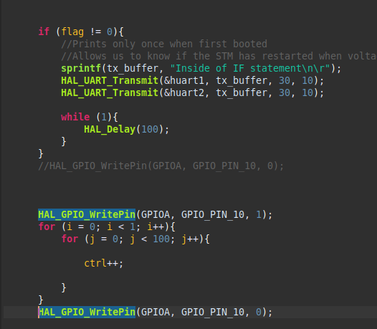

100 iterations
Only one example is given. More screenshots are given under VFI_Results_4 > 100 iterations.
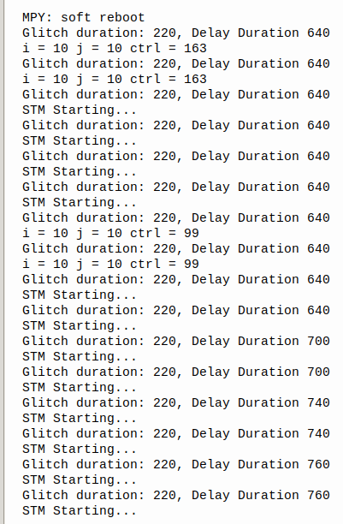

163 is observed

Skipping of instructions observed

10 iterations
Only one example is given. More screenshots are given under VFI_Results_4 > 100 iterations.

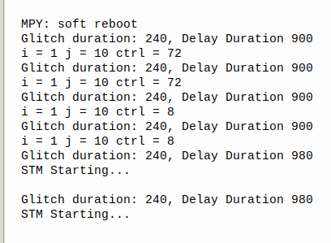

72 and 8 observed.

Comparism between 100 and 1000 iterations

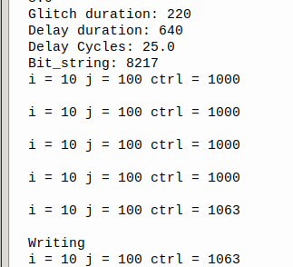

1063 was observed

Overall:
- 1061 to 1063 was observed in the 1000 iterations glitches.
- 10 + 62 = 72 (10 iterations)
- 100 + 63 = 163 (100 iterations)
- Likely points to the fact that the corrupted instruction was likely the adds instruction instead of the actual ctrl variable.

- Skipped instructions were also present

- Usually, one type of error happens per set of variables (delay and glitch duration), but sometimes, both errors can happen with the same set of variables.
- Rarely, 2 instructions can be skipped.

5 iterations with If statement

Code snippet:
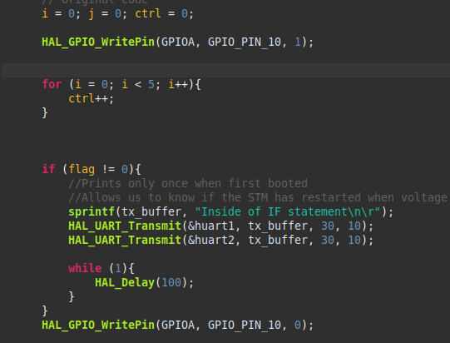

Disassembly:
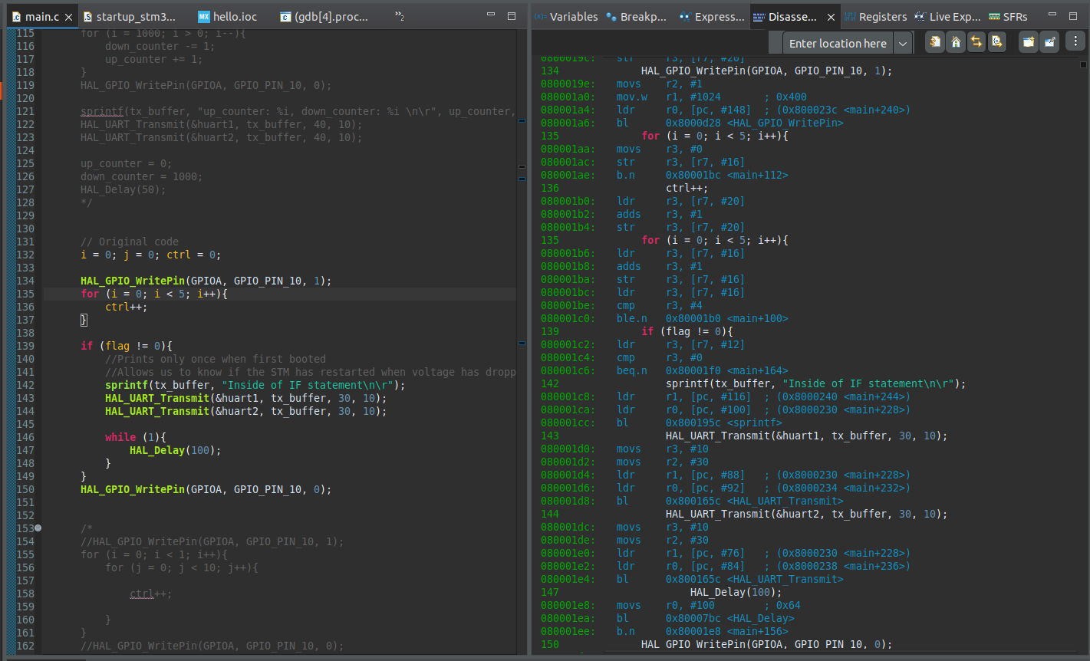

STM32CubeIDE Settings:

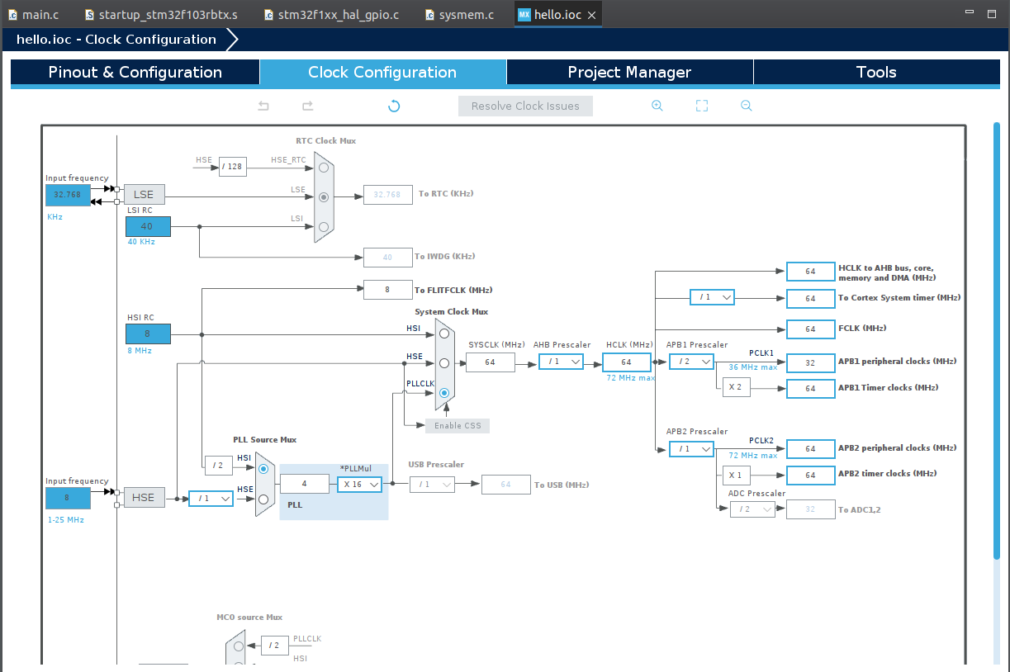

Running at 64Mhz

Glitch Waveform:

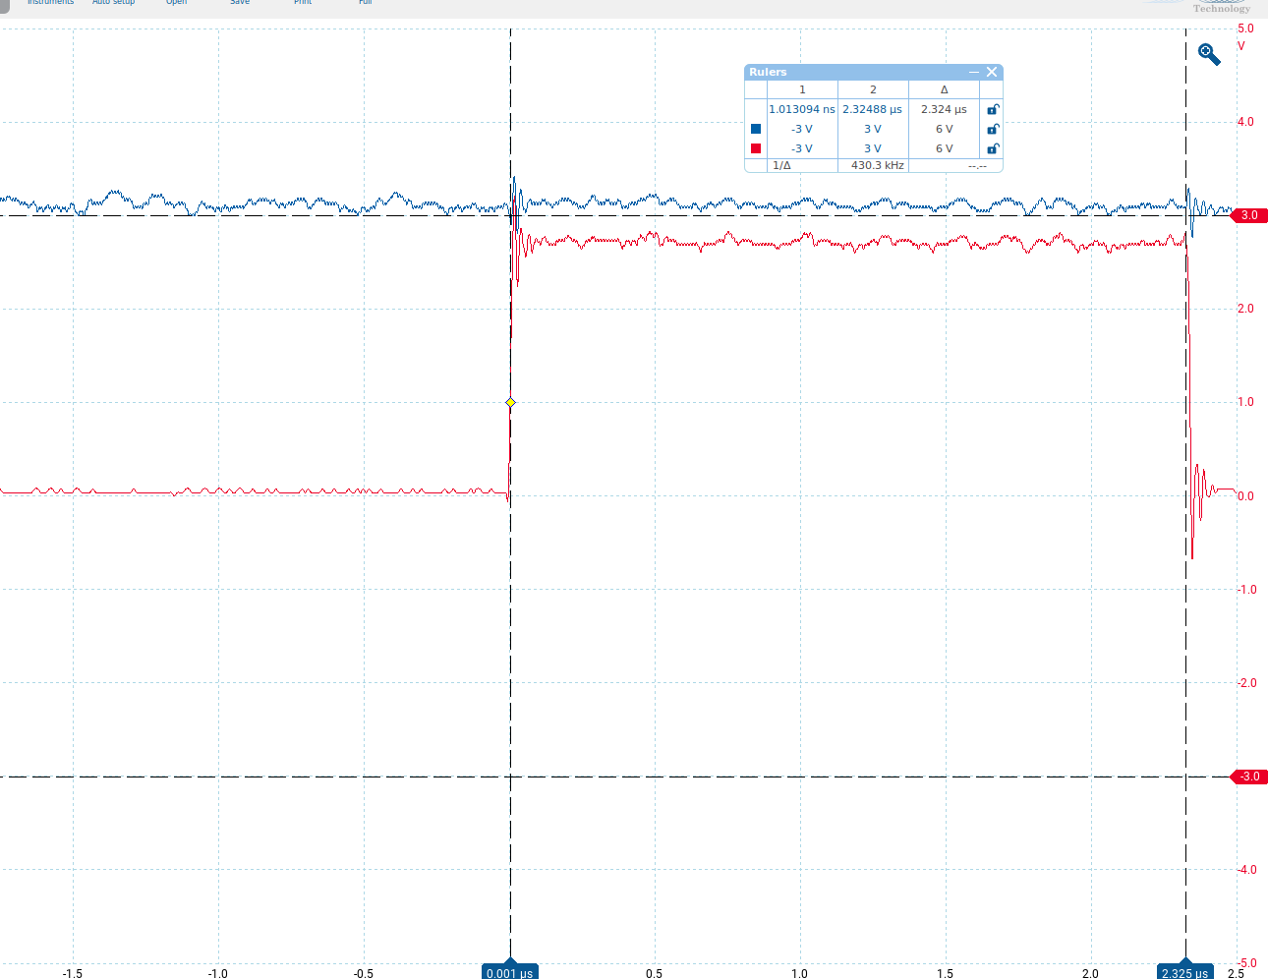
According to my calculations:
Number of instructions for “for” loop: 6 + 9x5 = 51 instructions
Number of instructions for GPIO to toggle: ~20 instructions
Total estimated time: 71/(64x10^6) = ~1110ns

However, the oscilloscope is reading almost twice of the calculated timing.

Possible explainations:
- Random delays?
- Clock speed is 32Mhz? I tried looking at the documentations of the bus used but nothing seems to be wrong?
Timeline:

GPIO for loop if statement Setting GPIO
finishing for falling edge
setup

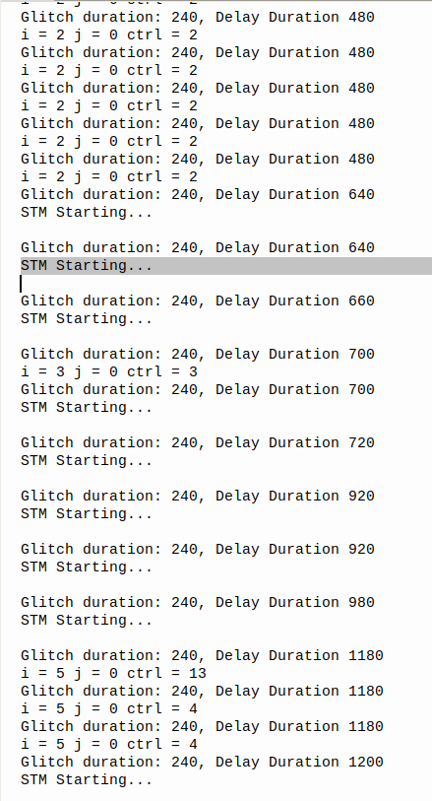
i variable glitched

ctrl or add instruction getting corrupted

skipped instructions
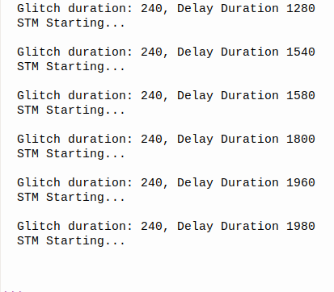

A few restarts after but no changes to I, j and ctrl.
Therefore, if statement should be approximately after 1200ns.

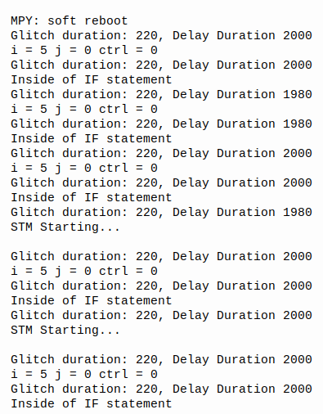
Consistent break into glitch statement found

Glitch duration was approximately at 1980 to 2000ns of delay.
There is also an accompanying corruption of data for ctrl.
Likely multiple lines of asm instructions were either skipped or corrupted.

Glitch succeeded at:
- Glitch duration: 230ns
- Delay duration: 1980ns to 2000ns

HOWEVER
Anomaly points found during testing:

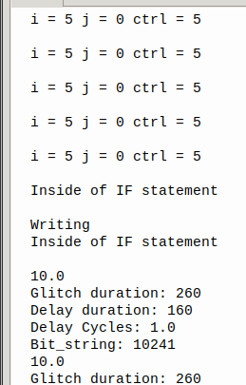

If statement entered at
delay duration = 140ns + 10ns (this run had extra cycle)
glitch duration = 260

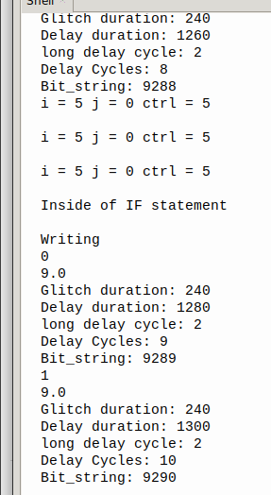

if statement entered at
delay duration = 1260ns
glitch duration = 240ns

Even if the glitch duration differed, the delay duration shouldn’t see such a large shift.
Likely bxlr instruction or pc register got affected in the process, jumping into the if statement.
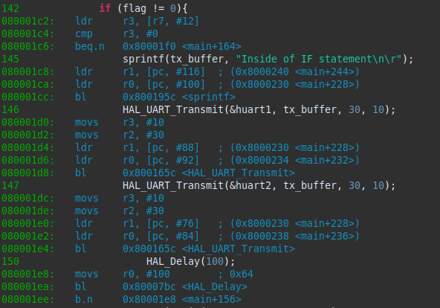
If conditional has a decently large address space to jump into.

if statement only

Waveform:
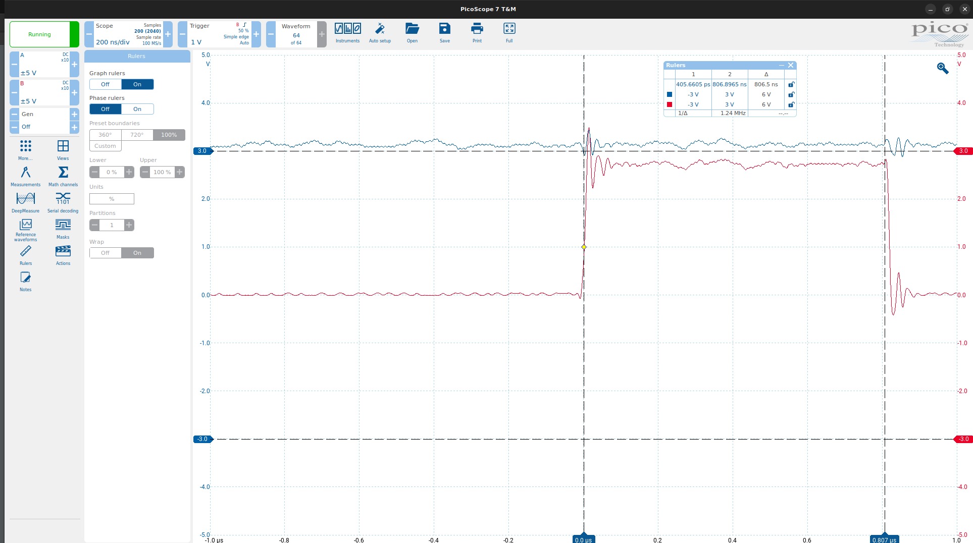
Disassembly
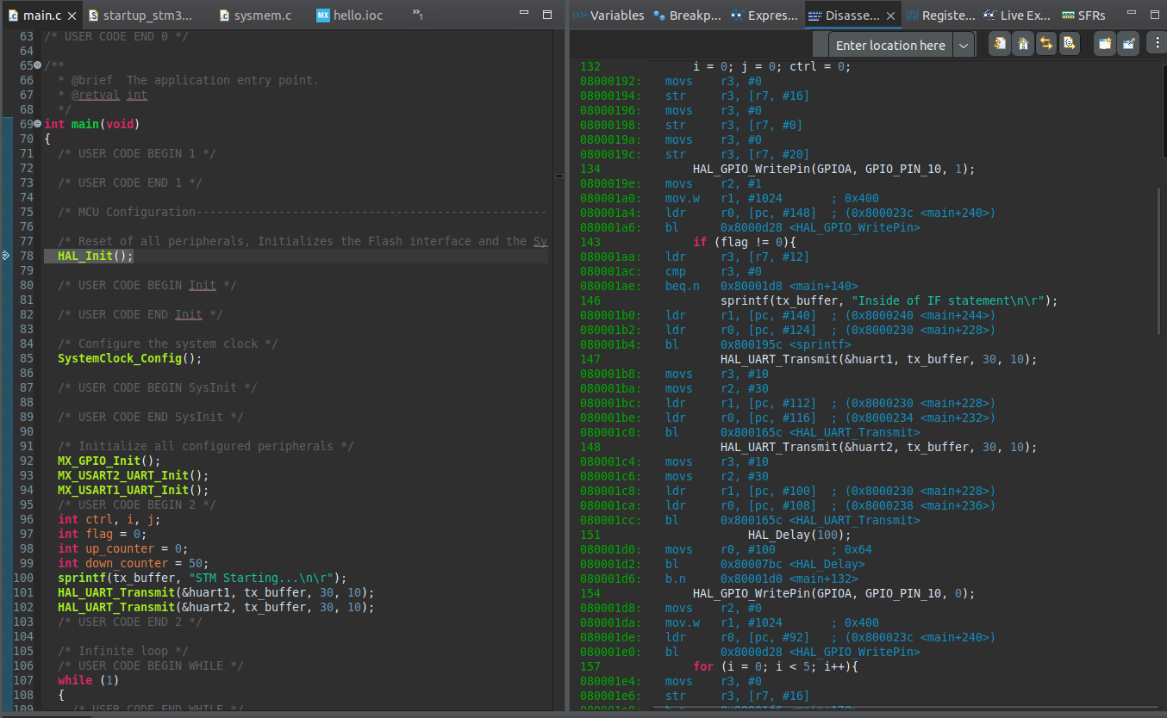
Once again, some discrepancies between expected and actual time when the signal is asserted.

Results:
- Using a for loop, iterated over the duration which the signal was asserted (from 140ns to 800ns)
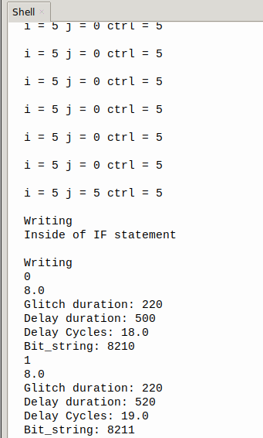

Glitch found at:
Delay: 480ns
Glitch: 220ns

To further test out glitching, I varied the delay and glitch durations.
Observations about glitching

Objective: Vary the glitch and delay durations in order to find if the range at which glitching can occur.

Base:
Delay: 480ns
Glitch: 220ns

Varying Glitch durations:
230ns
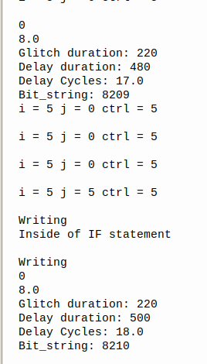

* Glitch works at 230ns

*j was also modified in the process, indicating the possibility of multiple instructions being glitched

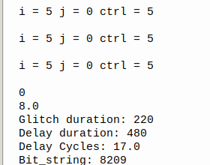

* However, crashes happens more often

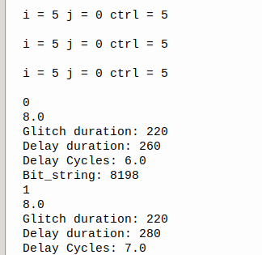

* Crashes also occur at other locations.

Other observations:
- Glitch does not work at timings >=240ns or <=210ns
- Crashes happen more often at longer glitch duration
- Sometimes, the STM32 will stop sending data over UART + oscilloscope readings turns weird, indicating that a crash occurs. After a some manual resets, the glitch is successful.

Vary Delay duration:
Delay Duration changed to 470 (images say 460 but one extra cycle was added to the PIO code)

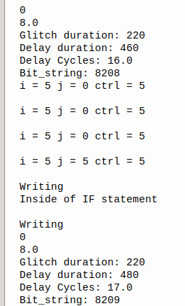

* Glitch successful at 470ns of delay duration

Some observations:
- No glitch was successful when delay duration was <=460ns or >=490ns

Conclusion:
There exists some leeway for successful glitches.
For Glitch duration: +-10ns from the “optimal” glitch durations
For Delay Duration: ~10ns leeway

Some external factors affecting the glitching process

Wires:
- Bumping into the wires/ slighly moving the wires changes the waveform still.
The waveform observed has a higher voltage floor.
- glitch and delay durations for successfully glitching into the if statement changes

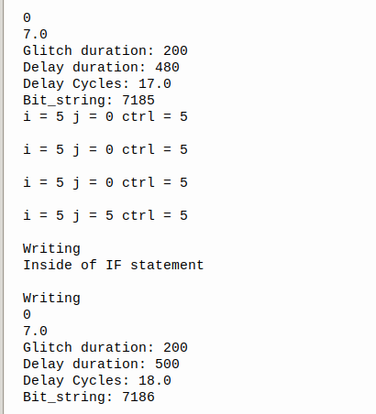

Glitch duration changed to 200ns

Glitch is also tighter with less leeway

- With the voltage floor of the glitch being raised, time below the operating voltage of the STM32 also decreases. Therefore, it is expected to have a tighter delay duration.

- This is also slightly helpful as it allows me to manually make very slight changes to the glitching process.

- I have tried to reduce this as much as possible by connecting the wires to the wire-wrapped pins directly, however, there is still some variation.

- Some of the holes of the circuit board is faulty(?). Oscilloscope probe does not read properly. Easy fix but worth noting.

